**GITHUB Task -1**

**Create a github account**

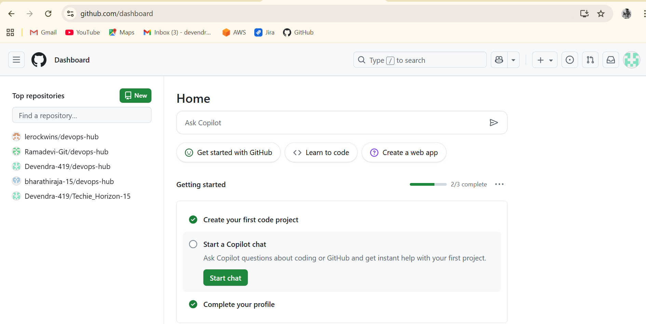

**2) Set up MFA (multi-factor authentication) for the github account using a mobile app.**

* Go to settings and choose password and authentication
* Enable 2 factor authentication
* Scan the QR code in the authentication app in your mobile

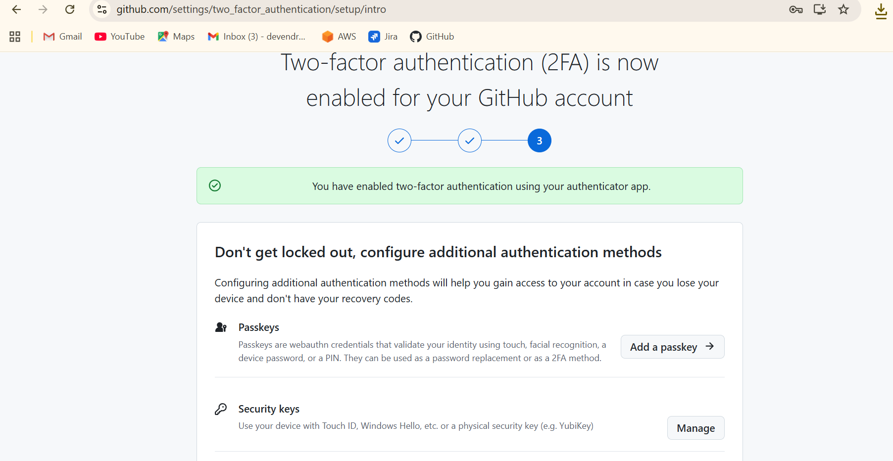

**Commands:**

* Create a folder in the local machine named as hiring app

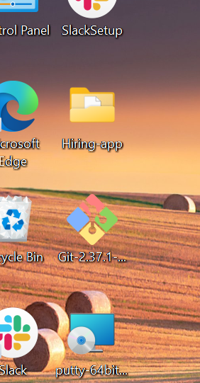

* If you want to check git version use : **git –version**

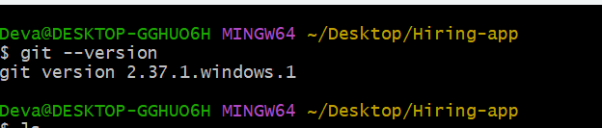

* **git status** -when you initializes it help us to check the changes in your repository

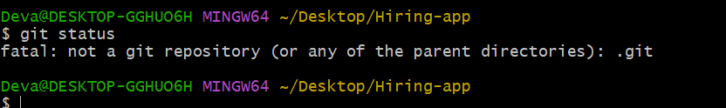

* **git init –** It initializes the repository

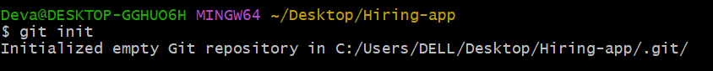

* **ls –**a - it shows the hidden files

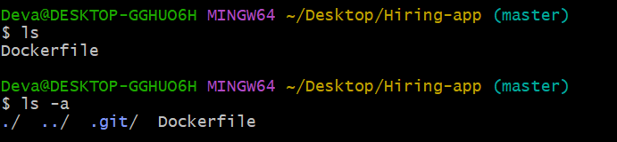

* **.git/** - Any configuration related details are stored in this

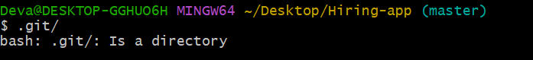

* **Cd .git/** - change directory to .git/



* **ll** – it gives long list

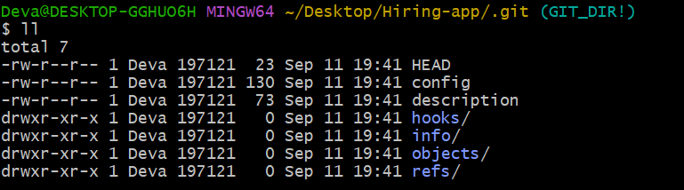

* **cd .. –** One step back
* **touch a** -create a zero bytes file
* **git status** - to track the changes in particular repository

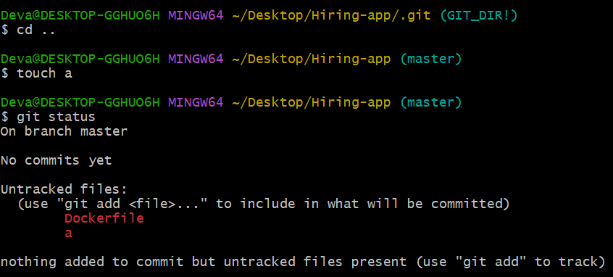

* **ls** -a – it shows the hidden files and files
* **rm** –rf .git/ - removed the .git/
* **git status** - to track the changes in particular repository

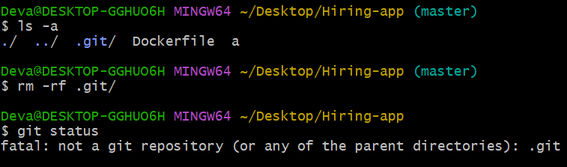

* **git config -- list –** This will help us to get the all complete details

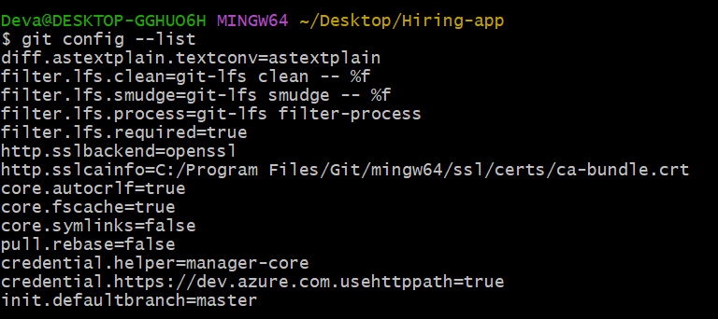

* **git config –global user.name”username” –** To add username



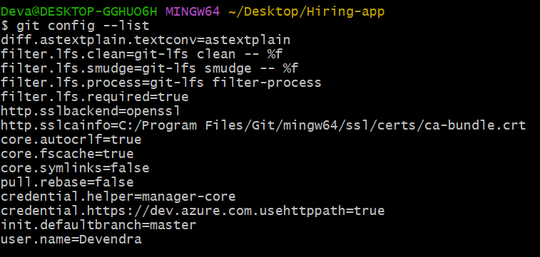

* **git config –global user.email”username@mail.com” -** To add usermail
* **git config** **–list -** it shows configuration details

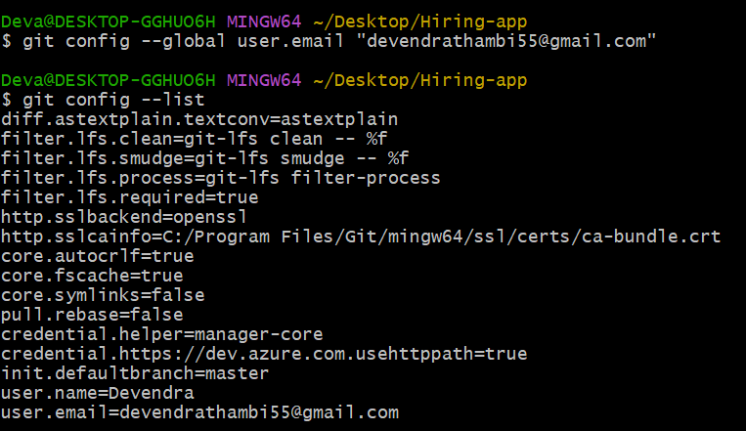

* **git add filename –** it adds file from untracking area to tracking area

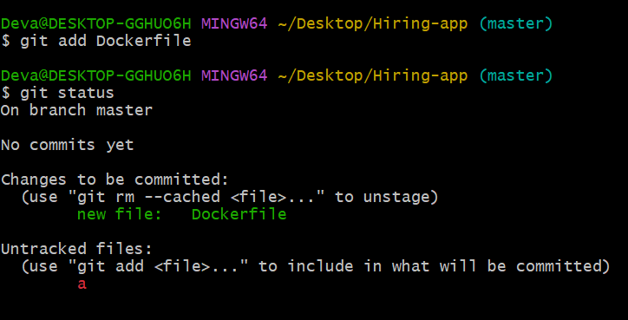

* **git add.** –it adds all files from untracking area to tracking area

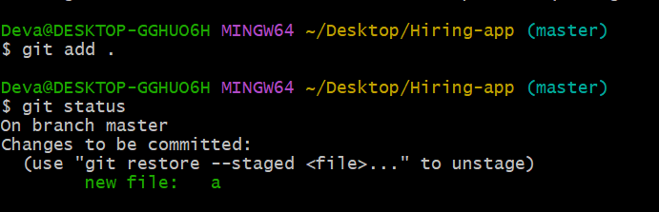

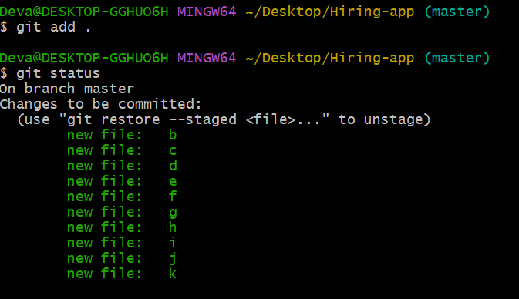

* **git commit –m “message”** - it will store a copy of changes with commit id

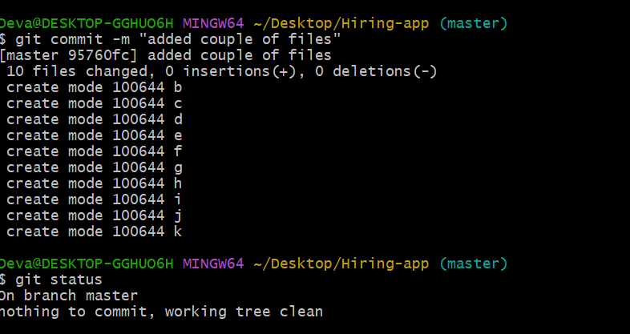

* **git log** – It will show the previous commit/changes that have made

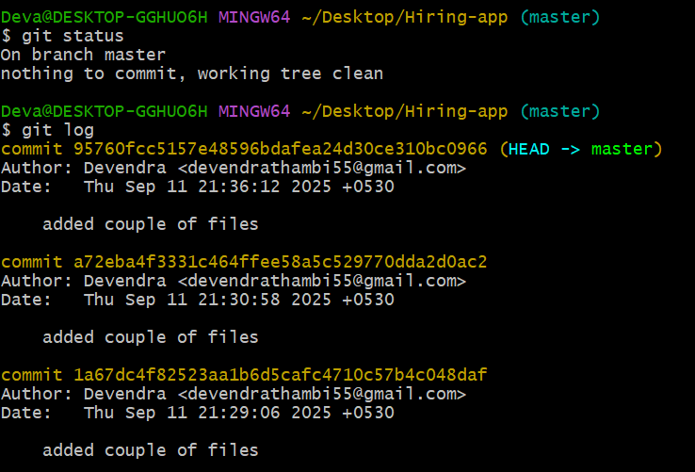

* **git remote add origin SSH-GitHub-URL -** it will add GitHub repo



* **git remote –**v – It shows list of GitHub repo that have added before

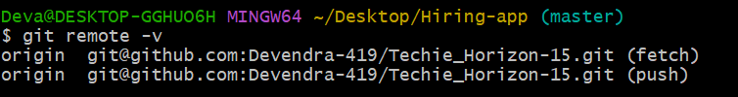

* **git push –u origin master / git push –** it will push changes to GitHub repo

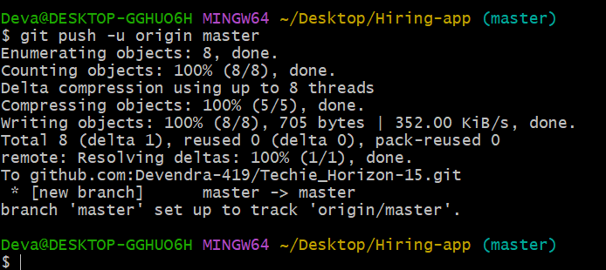

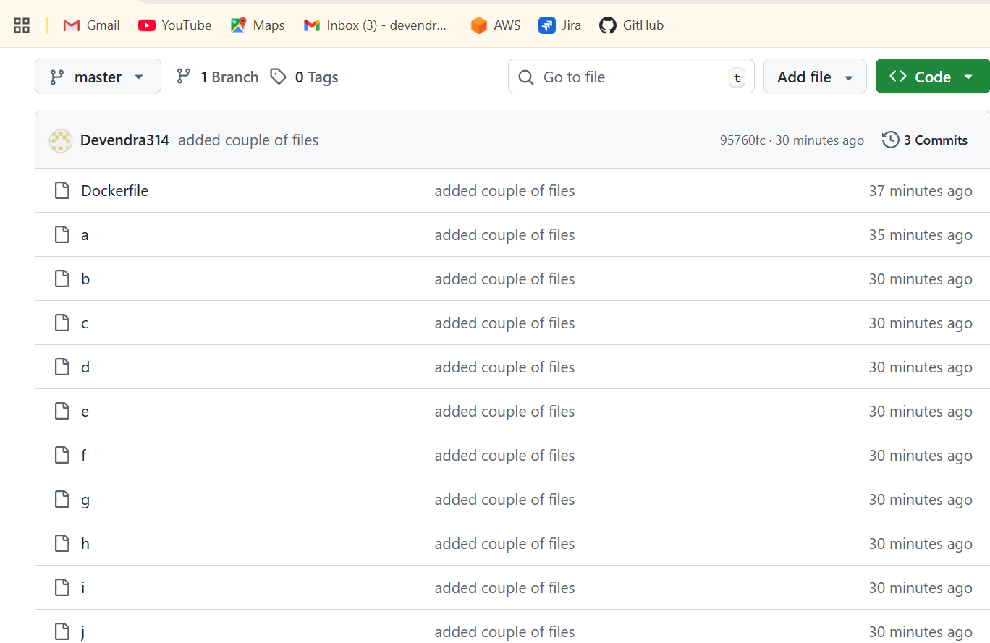

* **git clone github-repo-URL** - it’ll downloaded all data from github

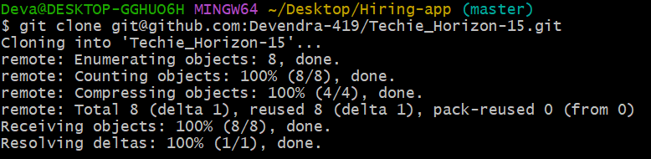

* **git pull** - it’ll changes from GitHub repo to our git repo

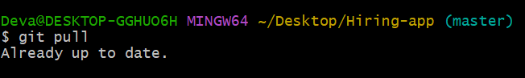

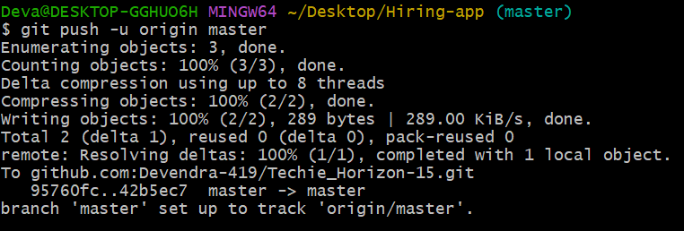

* **git log -4 –** it gives 4 log files

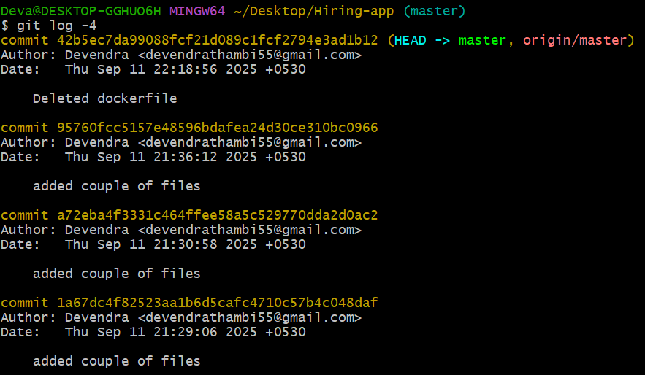

* **git revert <commit_id>** - It’ll try to go to previous commit

